# Chapter 3: Communicating Across Differences

A professor of intercultural communication and management highlights Ghosn’s lack of “the key intercultural competence needed by all those working across cultures: self-awareness, the ability to perceive and reflect upon himself.” Leaders who work across differences also must practice curiosity and humility.

## Shifting Your Mindset

Working across differences tests our character, particularly our willingness and ability to put ourselves aside at times in favor of others’ ideas, values, and cultures. You learn strategies to shift your mindset and approach yourself and others with more humility and curiosity than judgment.

**Acknowledging Your Own Cultural Identities and Views**

When people think of diversity, they often jump to differences in race and gender, but Diversity is far more complex. At work, people differ by **skill set, education, experience, thought, workstyles, sexual orientation, socioeconomic status, generation, physical abilities, family status, religious beliefs, political beliefs, core values—and by race, ethnicity, and gender.**

Diversity doesn’t mean a particular group of people; we are all diverse. An obvious example is in workstyles. When you start working with a team, you notice how differently people approach a project. Stephanie sees only problems, Kai jumps right to a solution, and Tamika wants to put together a schedule. Consider your own affiliations and identities.

Communicating across differences doesn’t only mean adapting to *others*. Through our interactions, we come to understand and accept *ourselves* in new ways.

Self-awareness is key to intercultural communication (or cross-cultural communication), which takes place between people from different cultures. When we talk about culture, we mean the customary traits, attitudes, and behaviors of a group of people. **More broadly, multiculturalism refers to appreciating diversity among people, typically beyond differences in countries of origin**.

You might take the first step in shifting your mindset about working across differences by asking yourself the questions –

**Questions About Your Identity and Views**

1. With what groups do I affiliate or feel as though I belong?
2. What is most important about my own cultural identity?
3. What has shaped my cultural identity throughout my life?
4. What do others need to know about me to understand and respect me?
5. What is the hardest part of living up to my own cultural expectations?
6. When have I felt ashamed of who I am?
7. When have others misunderstood or misjudged me because of my affiliation or identity?
8. When have I misunderstood or misjudged others because of their affiliation or identity?
9. How open am I to people who are different from me?
10. Do I interact regularly with people who are different from me?
11. Do I avoid interacting with certain people? Why?

Why do we misjudge people? We are all prejudiced in some way, which means only that we *pre-judge* others—a useful survival skill for early humans to avoid threats. Similarly, we stereotype people, which means we attribute to an individual an assumption we have about the group to which they belong that may or may not be true.

Of course, trouble follows when we take action based on wrongly held beliefs. Research on implicit (or unconscious) bias indicates that we have certain preferences or aversions and we are completely unaware or mistaken about them.

Companies recognize the dangers of implicit bias and have taken steps to make team members more aware. For example, HSBC, Deloitte, BBC, and Google have implemented blind hiring to reduce bias in the selection process. By redacting applicants’ name, address, dates, hobbies, interests, volunteer work, and/or college, companies hope to increase diversity and hire the best talent.

**Learning When We’re Uncomfortable**

We learn the most when we are uncomfortable. When we’re comfortable, we may be complacent, with our minds on autopilot. When we’re struck by fear or panic, we may be reactive, unable or unwilling to learn. When we are uncomfortable enough, we can learn. We recognize that what we believe to be true is questioned. We learn to reconcile our ideas with different ways of thinking, and we might learn that multiple truths exist. Changing your mindset takes courage.

**Reducing Blanket Judgments of Others**

In this section, you learn ways to reduce judgment of others, particularly negative judgments.

* You’ll increase understanding of yourself by asking why you’re judging
* choosing humility, observing without judging, getting perspective, being curious, and getting up close.

**Ask Why You’re Judging**

How we judge others might tell us more about ourselves than about the other person. Swiss psychiatrist Carl Jung said, “**Everything that irritates us about others can lead us to an understanding of ourselves”.** A coworker seems too pushy with customers. Is this true, or is the real issue that you hesitate to close a sale? Does another coworker really talk too much, or is the issue that you don’t get the airtime you want? When you’re judging someone, ask yourself the questions.

* Is it because of a preconceived notion?
* Is it because of my knowledge or experiences?
* Is it because of my strong values?
* Is it because of my limited view of the world?
* Am I biased?
* Am I jealous?
* Does the judgment hold true for me instead?

Being honest about your judgment may reduce its hold on you, allow you to view the other person more objectively—and help you learn about yourself. As a bonus, when we stop judging others, we tend to care less about what they think of us.

**Choose Humility**

**Humility is about human limits: seeing and handling our own and others’ limitations.** Humble leaders recognize that their view or way of being is not the only way of being. As a character dimension, humility is essential to communicating across differences because it drives our self-awareness and willingness to learn. Because they accept that they could be wrong, Humble leaders don’t flaunt success; they don’t see themselves as better than others.

When people say Carlos Ghosn, the former leader of Nissan, lacked humility, they point to his Marie Antoinette–themed wedding in Versailles (with costumes), his brazen escape from the law, and his comparing his arrest to the attack on Pearl Harbor. These three actions painted Ghosn as someone who lacked humility, living extravagantly, evading justice, and making extreme statements to defend himself.

Humility is a strength at work and at home. Perhaps paradoxically, humble leaders have high self-esteem. They don’t think less of themselves, but they think about themselves less. A humble leader asks, “What do others see that I need to see?” and “What can they teach me about myself?” When teams openly admit and learn from mistakes, they perform better.

**Observe Details Without Judging**

When we’re humble and realize that our judgments may be wrong, we can view situations more objectively. Training our minds to observe without interpreting or judging is challenging, and a regular practice of mindfulness and meditation can help.

Research shows that mindfulness reduces stress and work conflicts, and increases satisfaction and resilience. When we practice mindfulness, we train ourselves to stay present or “in the moment.” A beginner might experience greater clarity, comfort, and calm. Over time, mindfulness helps us observe thoughts and feelings without letting them overtake us—it gives us perspective.

**Practice Getting Perspective**

To expand our own point of view, we need the capacity to take different perspectives. Perspective taking means taking others’ points of view; we seek to understand others’ thoughts, feelings, and motivations. When people develop this capacity, they develop and repair trust, communicate more clearly, help others more, and reduce stereotyping and prejudices.

Try different strategies to understand other perspectives. “Zoom in, zoom out” is useful when we’re either too close to a situation to see the big picture or too far to see the detail. Amazon CEO Jeff Bezos is known for keeping one chair empty at meetings to represent the customer perspective. One study found that writing about challenges from others’ perspectives helped to shift thinking about certain groups.

The better approach is often to just ask. Find out why people believe what they believe. As researchers conclude, *getting* perspective is even better than *taking* perspective. We don’t simply imagine another point of view: we come to understand it by asking questions and by listening. That requires genuine curiosity.

**Be Curious**

Asking others about themselves and their perspectives demonstrates curiosity. We approach situations saying, “I wonder . . .” instead of “I know . . .”. In her TED Talk “Why You Think You’re Right—Even if You’re Wrong,” Julia Galef explains the difference between soldier and scout mindsets.

Soldiers want to overpower the enemy, so they are motivated by proving they are right and the enemy is wrong. Scouts map what exists even if it contradicts their own thinking. Galef says the scout mindset is open, curious, and grounded. In his book *Think Again*, Adam Grant encourages us to act like scientists. He explains, “instead of drawing conclusions about people based on minimal clues, [scientists] test their hypotheses by striking up conversations.”

## Managing Through Conflict

Like shifting your perspective, managing through conflict takes courage. In Chapter 2, you learned that conflict is one type of team communication. Although people often want to avoid conflict, doing so restricts personal growth, team development, and work outcomes. Without conflict, teams don’t experience harmony; they experience apathy. No one cares enough to challenge others’ ideas and, therefore, the best ideas don’t emerge.

**Assessing Types of Conflict**

Three types of conflict are common in organizations. Task conflict involves the work: assignments, resource allocation, goals and expectations, and policies and procedures.

Relationship conflict occurs when personalities or styles differ. These conflicts can stymie a group by eclipsing task conflicts. In other words, when people don’t like each other, they see only the personality issues and can’t hear useful differences about tasks.

Values conflict can be caused by differences in politics, religion, morals, identities, and other factors. Differences in such values as security, achievement, and status can affect group process quickly and are often overlooked. When managed well, these types of conflicts may improve team cohesion, effectiveness, and satisfaction. Unhealthy conflict damages work output and relationships.

More problematic conflict arises when people are uncivil. Workplace civility means showing respect and concern for others—a baseline way of interacting at work. Workplace bullying negatively affects work and relationships and leads to people feeling unsafe.

Cyberbullying is increasingly common online, and the effects are particularly harmful and difficult to control. Anonymity, a large audience, and direct access to the victim offer cover and fuel to a bully, and the permanent nature of content causes lasting problems .

**Deciding Whether to Engage in Conflict**

Before taking action to address a conflict, check yourself, as you would when applying the CAM model. What is your motivation? Be sure that your goals reflect good character—wanting better outcomes for others—rather than self-righteousness, a steadfast belief that your way is the right way.

Also check your mental and physical state. It sounds basic, but are you hungry or tired? Would you view the situation and react in the same way tomorrow or next week? Everyone has bad moods, including your teammates. Let fleeting issues pass. Not every eye-roll or negative comment needs to be addressed.

After checking yourself, consider the risks. What’s at stake for you personally and professionally if you do or do not take action? Consider the risks and questions –

**Risks of Taking Action to Address a Conflict**

**Ambiguity**

Can I accept unclear and conflicting perspectives, including my own? Am I willing to accept that my assessment may not be correct?

**Vulnerability**

Am I willing to be exposed emotionally? Can I withstand public judgment and feeling ashamed, even if I’m wrong?

**Loss**

What do I risk personally and professionally by taking action? Could I be ostracized/disliked, and will I damage relationships? Could I get fired?

With answers to these questions, you’ll decide whether the potential positive outcomes outweigh the risks.

You may be tempted to leave a team or a job to avoid conflict. Sometimes that is the best option, particularly if you’re in an abusive situation. But most times, addressing conflict is the better, more courageous choice. In his classic book *Exit, Voice, and Loyalty*, Albert O. Hirschman discusses the tradeoffs between voicing complaints and leaving an organization. Amazon employees could quit instead of complaining about the company’s impact on the environment or lack of work breaks. They risk quite a lot in speaking up. But leaving does nothing to solve the problem they care about deeply and may harm the company in the long run. Also, when individuals quit, they leave others to carry more weight.

The more constructive choice is to use their voices and demonstrate loyalty to their cause, to each other, and ultimately, to the company.

**Engaging Productively**

Once you decide to engage in a conflict, first identify the type. Task, relationship, and values conflicts should be approached differently .

**Task Conflicts**

Think of task conflicts as group problems. It’s tempting to defuse conflicts by making one member a scapegoat: “We’d be finished with this report by now if Sam had done his part; you can never depend on him.” Rarely is one person solely responsible for the success or failure of a group effort. Were expectations clear to Sam? Was he waiting for data from someone else? Did he need help but couldn’t get it from the rest of the team? **What is the team’s role in encouraging or allowing behavior, and what can each of you do differently to encourage more productive behavior?**

Task conflicts may seem easy to resolve, but underlying issues related to relationships and values may be at play. Try to get underneath the surface disagreement. For example, differences about scheduling may reflect deeper value differences around work quality or work–life balance.

**Relationship Conflicts**

Relationship differences may be addressed best by getting to know people personally and coming to appreciate what is different about each of you. Also find commonalities so you can focus more on your similarities than on your differences. If your personality differences seem insurmountable, try to separate the person from the idea.

On a team, it takes a brave leader—an official leader or any team member—to address relationship conflicts directly: “I’d like to talk about how we interact with each other at these meetings. It seems like we often end up fighting—it’s not productive, and someone usually gets hurt. Does anyone else feel that way? What can we do differently?”

**Values Conflicts**

Values conflicts may be resolved by affirming others’ positive qualities. Do you respect your teammates’ integrity? Can you acknowledge that they stand up for what they believe? Some values conflicts may never be resolved but could bring about greater understanding and deeper relationships. In these situations, your humility will be tested as you pursue a dialogue rather than inflict your views on others.

If teams did their work in getting to know each other, as discussed in Chapter 2, conflicts will be minimized and easier to resolve, but they will never be eliminated.

## Engaging in Difficult Conversations

In the end, work conflicts often come down to communication—a difficult conversation. According to authors of the book *Crucial Conversations*, people tend to handle these situations either with silence (sarcasm, sugarcoating, avoiding, or withdrawing) or with violence (controlling, labeling, or attacking). In this section, you learn better approaches to prepare for and encourage dialogue during a difficult conversation, including when to give and receive critical feedback.

**Preparing for a Difficult Conversation**

Before, you prepare for the physical (or virtual) interaction, prepare yourself emotionally and mentally. You might be tempted to fire off a text message, but richer communication channels are best for these challenging interpersonal situations. In-person conversations are ideal, and video or the phone can work, particularly if that’s how you typically communicate.

**Prepare Yourself**

* What is the situation or problem that you need to address?
* What do you hope to accomplish? Be specific about the ideal outcome.
* What assumptions do you have about this situation or about the person?
* Which of these assumptions do you need to confirm or clarify?
* What could be the reasons for the behavior from the other person’s perspective?
* In other words, could you be wrong about some of your interpretations?
* Does the person have good intentions even if the behavior is a problem?
* How might you, intentionally or unintentionally, be contributing to the situation?
* Be careful about blaming others without examining your own responsibility.
* How do you think the person might respond? Prepare for a few possible reactions.

**Choose a Time and Setting**

When could be a good time for you and for the other person to discuss the situation? When will you have enough time and space, so you are not rushed or distracted by other meetings or issues? Allow for extra time in case the conversation runs long.

Are you ready to listen openly to another point of view? If you are not ready, postpone the conversation until you are.

Ask for permission to start the conversation. You might say something like, “I’d like to talk with you about something sensitive (or difficult). Is now an okay time?” or “I like to talk about ______________. When is a good time for us to meet in the next couple of days?”

If you meet in person, find a private setting where you won’t get interrupted. Depending on the issue, emotions may run high, or the information may be confidential.

**Encouraging a Dialogue**

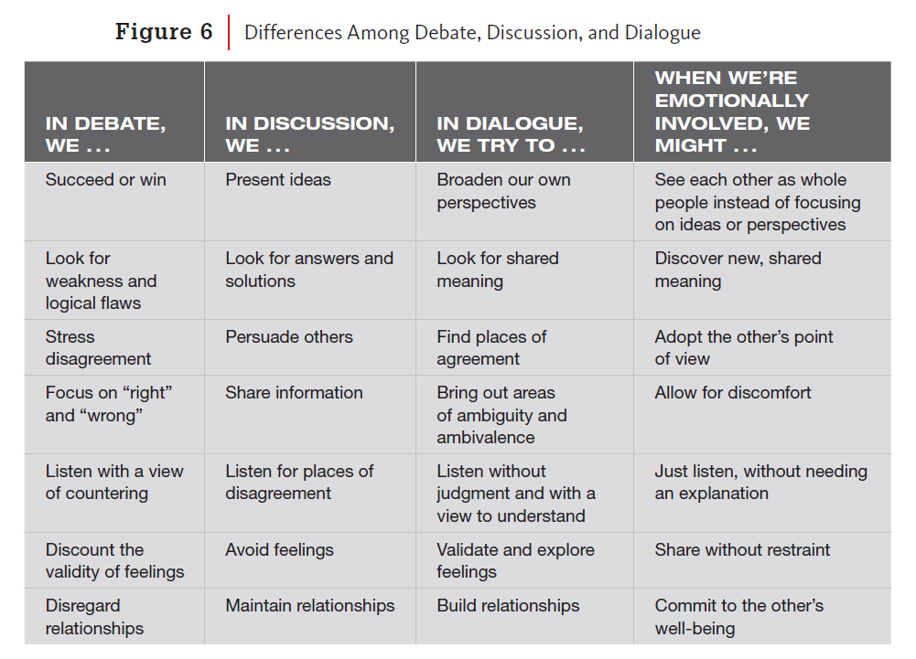

Dialogue requires a good start, active listening, sharing your perspective, problem solving, and ending well. Follow the suggestions below.

**Start the Conversation**

***Begin the conversation positively and focus on shared goals—what you have in common.***

* Approach your manager: “I’d like to talk about the project lead position. I know that Alibaba is an important client, and I’m disappointed that I wasn’t selected.”
* Approach a coworker: “I have concerns about our interaction during the meeting yesterday. I’d like to tell you what I observed [or how I feel], and then I’d like to hear your view. I think we have different perceptions about this, but I know that we both want the department to be represented well.”

**Listen Actively and Openly**

***Try to just listen while the person shares other perspectives.***

* Encourage the person to keep talking until nothing else needs to be said.
* Say, “Tell me more . . . ,” “I see . . . ,” and nod your head to let the person know you are listening attentively and not judging.
* Keep listening until you *really* see where the person is coming from. You may not agree with the person’s choices or behavior, but you can almost always understand a situation from another point of view.
* Try the active listening techniques discussed in Chapter 2, such as paraphrasing what the person says into your own words. Keep perfecting it until the other person agrees that you fully understand.

**Share Your Perspective**

***Describe your observations and reactions.***

* Focus on behaviors instead of making global statements. “I was upset when you asked Margot to lead the project instead of me,” rather than, “You always ask Margot,” “You don’t trust me,” or “You never give me a chance.”
* Explain as much as you can about why you hold your perspective. “I hear that Margot has more experience with the client. At the same time, I have more experience with the system, and I wrote most of the proposal.”
* Be honest about your own vulnerabilities, defenses, or baggage. “Something similar happened at my previous job, and I’m wondering what I can do differently to give you more confidence in my abilities.”
* Take responsibility for your part. “Maybe I wasn’t clear about how important it was for me to work with this client” or “Maybe I needed to step up more during the planning phase.”
* Consider sharing your perspective before asking the other person’s perspective, depending on the situation.

**Problem-Solve**

***Discuss how you can work together to prevent a similar situation in the future.***

* Ask the other person for ideas and try to acknowledge and build on them.
* Offer your own suggestions—what you can do differently and what you would like from the other person.
* Try to find a shared purpose or outcome for the larger organization. What will be improved in addition to your relationship?

**End the Conversation**

***Try not to rush the closing.***

* Summarize the results and check that the other person agrees with the conclusions or planned steps.
* Thank the person for speaking with you, and end on a positive note.

**Reflection in Action**

1. Intellectual Reflection

* Are you getting the results you want? Why or why not?
* How is the person (or people) reacting to you?
* What do you observe about the others’ tone of voice or body language?

1. Emotional Reflection

* How do you feel right now? Are you frustrated, angry, annoyed, satisfied, excited, hopeful, or something else?
* How are your emotions affecting the interaction? Are they encouraging cooperation and support, or are they getting in the way?

1. Physical Reflection

* What is your body language right now, and what is it communicating to the other person?
* How do you feel physically? Does your physical feeling denote an underlying reaction that is inconsistent with the character you want to demonstrate?

**Giving and Receiving Constructive Feedback**

One example of a difficult conversation is when you give or receive constructive (or negative) feedback. Imagine a work environment—or a class—in which you never receive feedback on your performance. How would you know what you do well and what skills you need to develop? Feedback is the only way to know what needs to be improved.

Giving and receiving feedback needs to be part of a team’s culture—how you’ll work together. In her book *Radical Candor*, Kim Scott supports an honest, open approach to giving feedback. **Practicing radical candor means that you know and care about people personally and, at the same time, challenge them directly.**

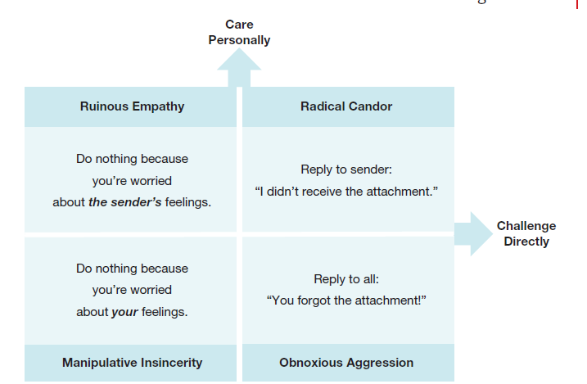

Focusing on the specific behavior instead of the person and taking responsibility for the feedback will improve the chance that the discussion will go well.

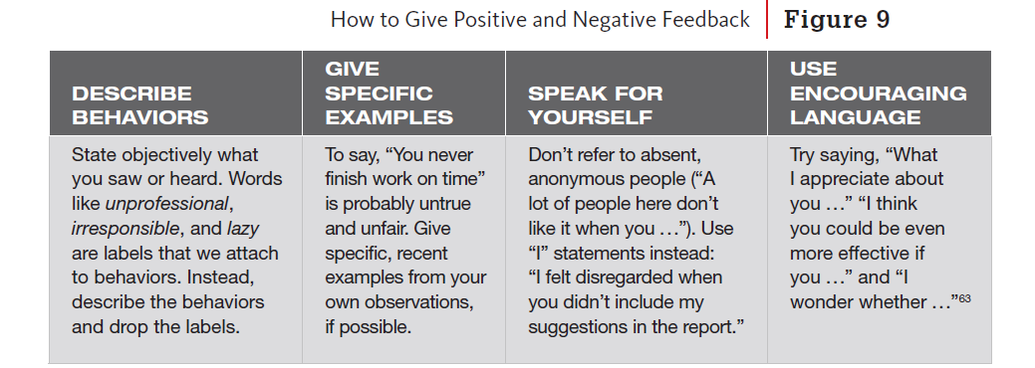

Typically praise in public but criticize in private. Your goal is to change behaviors—not embarrass people.

## Communicating to Improve Inclusivity and Belonging

**Understanding Diversity, Inclusion, and Belonging**

Because of the business benefits, smart companies value and recruit for diversity. Apple defines diversity broadly and mentions “including everyone”. Many companies today go beyond demographic diversity and strive for inclusion and belonging.

Diversity is a baseline objective: companies simply count the numbers of people. Beyond the numbers, inclusion is about behaviors, such as inviting people to meetings and implementing their ideas. Belonging is the highest level of achievement—how people feel. Do people feel valued? Do they feel as though they are part of a community?

Belonging is the newest concept and aims to address employees’ feelings of isolation. When asked to distinguish between belonging and fitting in, an eighth grader said, “**I get to be me if I belong. I have to be like you to fit in.**” This wise student is also describing authenticity.

**Bringing Your Whole Self to Work**

At the beginning of the chapter, you reflected on your affiliations and identities. How comfortable are you “bringing your whole self to work,” We judge a person’s character partly by how genuine they seem? Are they authentic and real, or do they put on an act for different people in different settings? One study found that 75% of employees want their colleagues to share more of themselves.

Being authentic at work has personal benefits. When people share more of who they are, they report greater job satisfaction, a stronger sense of community, lower job stress, and higher. levels of engagement. People who carry secrets experience more stress and negative health effects. A study of people who concealed their sexual orientation showed that the secret quite literally “weighed them down,” as the expression goes. They found physical tasks more difficult and were less likely to offer others help with physical tasks.

Management researchers suggest that you consider the timing and relevance and how much you share. Also pay attention to what and how others share—and their reactions to your disclosures. Put safety first; you may choose not to disclose information that could cause intolerable harm.

In addition, being authentic doesn’t mean being a narcissist—it’s not all about you. Oversharing personal aspects of yourself, feeling inferior or superior because of your identity, or lacking empathy for others are not healthy features of authenticity. Don’t expect immediate intimacy from others. By being trustworthy and with measured vulnerability, you’ll develop relationships over time.

**Using Inclusive Language**

Communication, particularly language, is an important part of fostering belonging in an organization. How we interact with people affects how they feel about themselves and ultimately how they contribute.

Terminology used to refer to groups is constantly evolving because of preference and because terms become dated and carry negative connotations. English actor Benedict Cumberbatch referred to Black actors as “colored.” An Ohio State Senator and medical doctor made the same mistake and threw in a racist generalization. He was fired from his job at a health care company. People have little tolerance for outdated terms.

Most of the following advice is from the American Psychological Association (APA) Style guide, a good source for current language.

**Race and Ethnicity**

APA style explains the difference between race and ethnicity: ***Race***refers to physical differences that groups and cultures consider socially significant. For example, people might identify their race as Aboriginal, African American or Black, Asian, European American or White, Native American, Native Hawaiian or Pacific Islander, M¯aori, or some other race.

*Ethnicity* refers to shared cultural characteristics such as language, ancestry, practices, and beliefs. For example, people might identify as Latin or another ethnicity.

* Be clear about whether you are referring to a racial group or to an ethnic group. Race is a social construct that is not universal, so one must be careful not to impose racial labels on ethnic groups.
* Whenever possible, use the racial and/or ethnic terms that your participants themselves use.
* Be sure that the racial and ethnic categories you use are as clear and specific as possible. For example, instead of categorizing participants as Asian American or Hispanic American, you could use more specific labels that identify their nation or region of origin, such as Japanese American or Cuban American.
* Use commonly accepted designations while being sensitive to participants’ preferred designation.
* What we call ourselves is not a trivial matter. The terms used to refer to other groups are not ours to establish, and it’s easy enough to use terms that others prefer.

**Gender**

Avoid confusing *gender* and *sex* in your writing and speech. Gender is a social construct and reflects how people feel and behave. Sex refers to someone’s biology. In most business situations, use “gender,” which also avoids associations with sexual behavior.

Differences in male and female communication styles may be exaggerated. As with most behaviors, more differences exist within a gender group than between groups.

Gender identity is how a person sees themselves—whether as male, female, both, or neither. The Human Rights Campaign explains that transgender people identify differently from the gender typically expected based on the sex they were assigned at birth. Some people use terms like “gender-nonconforming,” “genderqueer,” or “gender-nonbinary.”

Recognizing the diversity of gender identities, Facebook provides over 50 gender options for user profiles. Since not everyone identifies strictly as male or female, traditional pronouns like he, she, him, or her may not fit. It’s best to ask people what pronouns they prefer or use "they" until you know. While "they" was traditionally a plural pronoun, it is now widely accepted as singular. Other pronouns, like ze, xe, hir, and ey, exist but are not commonly used in professional settings. Whenever possible, use gender-neutral language.

**Generations in the Workplace**

With people working longer, workplaces may have employees from up to five different generations. While stereotypes about age exist—such as younger employees viewing workers in their 50s as "older"—research does not support broad differences between generations. Instead, workplace issues often stem from personal biases. To create an inclusive environment, avoid making assumptions about workers based on their age and use neutral language.

**Sexual Orientation**

Although same-sex marriage is now legal and more accepted in the United States, can people who identify as LGBTQ (lesbian, gay, bisexual, transgender, queer/questioning, plus) bring their whole selves to work? Can they speak about their social and family lives just as straight people talk about theirs?

To pave the way for others, Apple CEO Tim Cook wrote “I’m proud to be gay,” an open letter in a major business magazine. Homophobic and heterosexist language is still far too common and should never be used in the workplace.

**Ability**

People sometimes feel uncomfortable interacting with people with disabilities. Avoid making assumptions based on your observations. Physical disabilities say nothing about someone’s intelligence, and people may live with many disabilities, such as mental illness, that aren’t visible.

Depending on the situation, just use your natural way of speaking and eye contact, or you might ask if someone needs assistance. Try to be yourself and be patient.

Instead of using potentially disparaging language, choose “people-first language” unless someone prefers otherwise. With people-first language, you identify the person before the disability; for example, say, “people with disabilities” and “Alejandro is a sophomore who has epilepsy.”

**Religion**

Whether we were raised in a certain tradition or adopted it later in life, religion helps people create meaning in their lives. At many companies, discussing religious beliefs, like political beliefs, is discouraged. But some companies allow people to practice what is most important to them during the day. Texas Instruments, Gogo, and other companies have dedicated prayer rooms for their employees. At the same time, people who don’t practice religion should not be forced to do so. Unless the organization is identified with a particular religion, and new hires know this before accepting a job, managers should not, for example, ask employees to pray before business meals.

Be mindful about religious differences. Not everyone wants to hear “Merry Christmas” when they don’t celebrate the holiday. Try to avoid assumptions based on appearance, names, or the majority.

**Offending and Taking Offense**

“Walking on eggshells”—carefully measuring every word we say—is no way to work. We can’t build trusting relationships if we avoid topics or people, for fear of offending them. We will offend sometimes and will be offended other times. We all make assumptions that aren’t accurate or use terms that unintentionally offend.

In her book *35 Dumb Things Well-Intended People Say*, Maura Cullen tells about using the word *blackmail* during a meeting, which someone found to have racial connotations. Was the woman being overly sensitive? Who’s to judge? Cullen didn’t; she simply replaced the word with *coerced* and then spoke with her colleague after the meeting so they could understand each other better.

Apologies may repair a relationship but only if they are genuine. Taking the time to understand the offense and how it affected the other person are key and may bring you closer in the long run. Ibram X. Kendi, historian and author of the bestselling book *How to Be an Antiracist*, writes, **“The heartbeat of racism is denial, and the heartbeat of antiracism is confession.”**

When something offends you at work, you have every right to say so. Try to focus on your reaction instead of on the other person. Calling someone a racist likely won’t improve your working relationship or change the person’s behavior. Use the tips for engaging in conflict and managing difficult conversations. With a constructive approach, you’ll contribute to the type of place where everyone feels valued and wants to work.

## Adapting to International Cultural Differences

To be successful in today’s global business environment, leaders need to appreciate international differences among people. Although English may be the standard language for business, by no means do we have one standard for all business communication. In this section, you learn ways to improve your adaptability and communication across international differences.

**Understanding Cultural Differences**

Cultures differ widely in what they value. For example, Figure 13 shows that international cultures vary in how much they emphasize individualism, time orientation, power distance, uncertainty avoidance, formality, materialism, and context sensitivity. Of course, differences exist within a country and can be dramatic even within the United States, given our diverse population, large immigrant communities, and differences between people who live in rural and urban places.

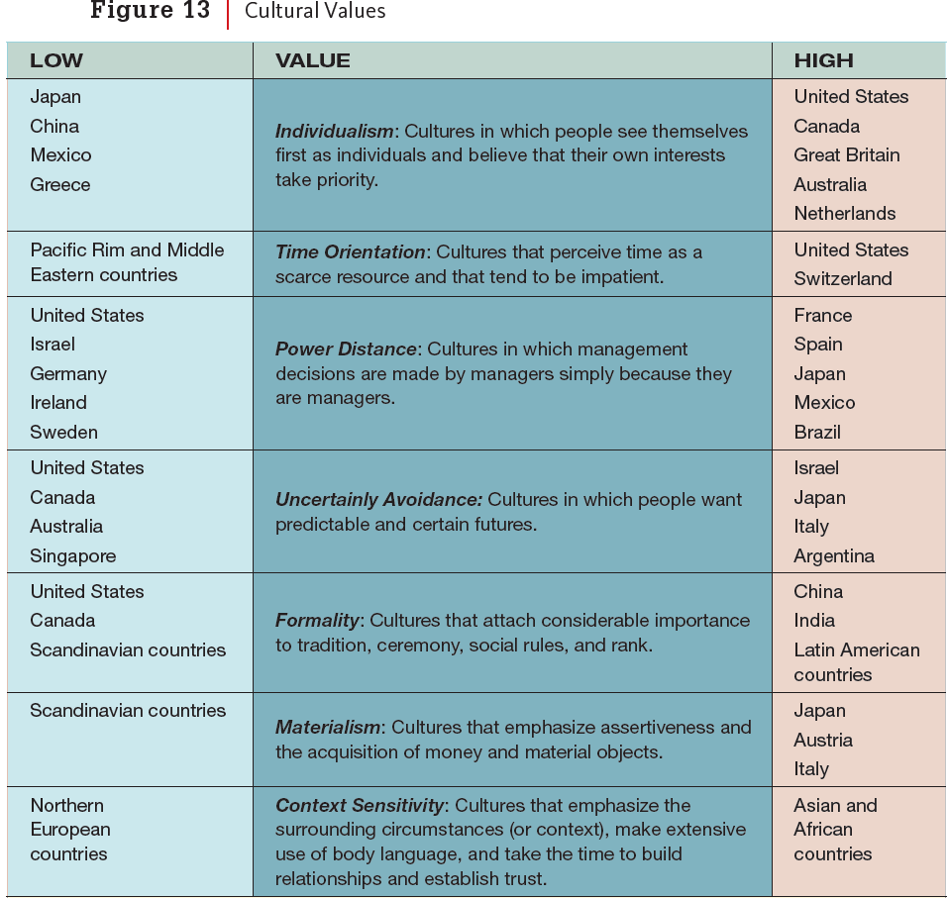

**Verbal Communication and Relationships**

1. **High-Context vs. Low-Context Cultures**
   * **High-context cultures** (e.g., China, Japan) rely more on non-verbal cues, subtle actions, and relationships rather than direct words.
   * **Low-context cultures** (e.g., the United States) focus on explicit verbal communication, with tasks often prioritized over relationships.
2. **Cultural Differences in Communication Style**
   * The American phrase, **“The squeaky wheel gets the grease,”** reflects a direct approach to communication.
   * The Chinese proverb, **“A harsh word dropped from the tongue cannot be brought back by a coach and six horses,”** warns against direct, emotional language, emphasizing careful word choice.
3. **The Role of Silence in Communication**
   * In **high-context cultures**, silence is meaningful and used for consideration/attention in meetings.
   * In **low-context cultures** (e.g., the U.S. and Canada), silence is often uncomfortable, leading people to speak quickly, sometimes offering unnecessary compromises.
   * Effective intercultural communication requires **reading between the lines**, as what is left unsaid can be just as important as spoken words.
4. **Regional Differences in the United States**
   * Some regions have **faster speech patterns**, while others allow more pauses between speakers.
5. **Cultural Differences in Advertising**
   * **Japanese Apple ad**:
     + Uses **symbolism** and **storytelling** through anime-style visuals.
     + Features adaptations of the Apple logo as a **pear, heart, and bitten apple** to create a subtle, culturally relevant message.
   * **American Apple ad**:
     + **Direct and bold** messaging, titled **“Greatness.”**
     + Features **famous Americans**, emphasizing **trailblazing personalities** and their achievements.
     + Uses a strong **voiceover and inspirational tone** to highlight individual success.

**Group-Oriented Behavior**

1. **Individualism vs. Group Orientation**
   * **Capitalistic societies** (e.g., U.S., Canada) emphasize **individual effort and competition**.
   * **Group-oriented cultures** (e.g., Japan) value **teamwork, consensus, and conformity** (e.g., the saying, “A nail standing out will be hammered down”).
2. **Job Applications in Different Cultures**
   * **Individualistic cultures**: Resumes highlight **personal skills, achievements, and experience**.
   * **Group-oriented cultures**: Employers prioritize **trustworthiness and loyalty**, often hiring people they or their colleagues know well.
3. **The Concept of “Saving Face”**
   * Avoiding embarrassment is important in many cultures.
   * **Example**: Toyota’s CEO, Akio Toyoda, showed **deep humility and emotion** when apologizing for recalls, in contrast to American business leaders like Boeing’s Dennis Muilenburg.
4. **Indirect Communication in High-Context Cultures**
   * In cultures valuing relationships, people avoid **direct confrontation**.
   * **Example**: Latin Americans rarely say “no” outright, and in Japan, “yes” can mean **understanding** rather than **agreement**.
   * Americans may perceive this communication style as indirect or overly wordy.
5. **Cross-Cultural Communication Challenges**
   * Example: During Toyoda’s congressional testimony, an American committee chair **demanded a “yes or no” answer**, which Japanese audiences found **rude and disrespectful**.

**Body Language and Gestures**

1. **Gestures Have Different Meanings Across Cultures**
   * **Example**: The “okay” hand sign has different meanings and, in some contexts, is now seen as a **hate symbol in the U.S.**
2. **Eye Contact and Cultural Perceptions**
   * **East Asians**: View **direct eye contact** as a sign of **anger or unapproachability**.
   * **Westerners**: See **eye contact as a sign of trust and connection**.
   * **Study**: Airbnb photos showed that **direct eye contact increased booking rates in the Netherlands**.

**Time Perception in Different Cultures**

1. **Time-Conscious vs. Flexible Cultures**
   * **Strict with time**: Switzerland, Germany, Britain, the Netherlands, Austria, Scandinavia, and the U.S. (**“Time is money”**).
   * **More relaxed about time**: Latin American and Middle Eastern cultures (**más o menos 3:00** means "more or less 3:00").
2. **Impact of Culture on Business Negotiations**
   * **Asian and Latin American cultures** favor **long negotiations and careful deliberation**.
3. **Situational Time Differences**
   * People **prioritize punctuality** for **important events** (e.g., job interviews).
   * Lateness in casual settings can **signal carelessness or arrogance**.

**Personal Space and Cultural Differences**

1. **Different Cultures Have Different Comfort Levels with Space**
   * **Americans**: Prefer **more personal space**, especially in public places like elevators.
   * **Middle Easterners & Latin Americans**: Feel **comfortable in close proximity** to others.
2. **Factors Affecting Personal Space Preferences**
   * **Culture, geography, and economics** shape personal space needs.
   * **Age, gender, and temperature** also influence comfort with distance.
3. **Post-Pandemic Shift in Space Preferences**
   * Concerns about **transmissible diseases** have changed how people feel about personal space.
   * **Social cues** (e.g., facial expressions, stepping back) help measure personal space preferences.

**Adapting to Different Cultures**

1. **Cultural Adaptability**
   * Requires an **open mindset**, similar to **conflict resolution and fostering belonging**.
   * Differences in international cultures may be more pronounced, requiring **flexibility**.
2. **Avoiding Ethnocentrism**
   * **Ethnocentrism**: The belief that one's own culture is **superior**.
   * Instead, develop **cultural competence, agility, and humility**.
3. **Key Cultural Skills**
   * **Cultural competence**: Understanding and engaging effectively with people from different cultures.
   * **Cultural agility**: Adapting smoothly to cross-cultural situations.
   * **Cultural humility**: Self-reflection and recognizing that **learning is ongoing**.
4. **Preparation for Cross-Cultural Interactions**
   * Learn about **geography, government, cities, culture, and customs** before traveling.
   * Understand cultural norms, such as **gift-giving, business card exchanges, and hospitality**.
5. **Formality in Business Interactions**
   * Many cultures prefer **formal business communication**.
   * Use **titles and family names** unless invited to do otherwise.
   * Maintain **professional verbal and nonverbal behavior** to show respect.
6. **Individual Differences**
   * Cultural norms are general guidelines, but **personality and status** influence preferences.

**Communicating Across Languages**

1. **Verbal Communication**
   * Avoid **slang, jargon, and idioms** (e.g., “out in left field”).
   * Use **clear, simple language** and **enunciate** without being condescending.
   * Be mindful of **grammar assumptions**—poor grammar does **not** indicate a lack of intelligence.
2. **Visual and Nonverbal Communication**
   * Use **handouts, visuals, and written summaries** for clarity.
   * Provide materials before and after meetings for better comprehension.
   * Use **facial expressions and gestures** appropriately to reinforce meaning.
3. **Pacing and Comprehension**
   * Pause for **processing time** when speaking with non-native speakers.
   * Ask **open-ended questions** to check for understanding (e.g., “What can I clarify?”).
   * Observe **facial expressions** and body language for signs of confusion.
4. **Encouragement and Support**
   * Be patient, smile, and nod to show **support**.
   * Avoid **interrupting or finishing sentences** unless asked for help.
   * Ask questions in a way that **does not single people out** or cause embarrassment.
5. **Advice for Non-Native Speakers**
   * Speak **slowly**, enunciate, and use **visuals** to aid comprehension.
   * Be honest about **language proficiency** without underestimating ability.
   * Confidence is **key to fluency**—mistakes are part of the learning process.
   * **Accents are normal**—even within a single country, people have different accents.

**Closing Thoughts**

1. **Ethical Issues in Global Business**
   * Example: Carlos Ghosn’s lavish **French wedding expenses** contrasted with workers’ wage protests.
   * Ethical lapses in leadership can **damage credibility and trust**.
2. **The Importance of an Open Mindset**
   * Cross-cultural communication requires **skill, humility, and flexibility**.
   * Despite preparation, **unexpected situations** will arise.
   * Viewing these experiences with **curiosity rather than frustration** makes the process more enjoyable.
3. **Next Steps: Business Writing**
   * The next chapter will focus on **business writing**, which also requires an **understanding of the audience**.